**TRANBY COLLEGE**

**Psychology (ATAR) – Unit 1**

**Task 3 | Biopsychology Test [2015]**

**Question/Answer Booklet**

Student Name

Group: ☐ Friday Session1 ☐ Friday Session 2 ☐ Offline

*Please tick your group.*

## TIME ALLOWED FOR THIS PAPER

Working time for paper: 75 minutes

## MATERIAL REQUIRED/RECOMMENDED FOR THIS PAPER

***TO BE PROVIDED BY THE SUPERVISOR***

This Question/Answer Booklet

***TO BE PROVIDED BY THE CANDIDATE***

*Standard Items:* Pens, pencils, eraser and ruler.

*Special Items:* Calculators satisfying the conditions set by the Schools Curriculum and Standards Authority (SCSA)–*no graphics calculators permitted.*

## *INSTRUCTIONS TO CANDIDATES*

**No other items may be taken into the assessment.**

**It is your responsibility to ensure that you do not have any unauthorised notes or other items of a non-personal nature in the examination room. If you have any unauthorised material with you hand it to the supervisor BEFORE reading any further.**

**Structure of this paper**

|  |  |  |  |  |
| --- | --- | --- | --- | --- |
| **Section** | **Number of questions available** | **Number of questions to be answered** | **Suggested working time (minutes)** | **Marks available** |
| Section One:  Research methods | 1 | 1 | 11 | 12 |
| Section Two:  Short answer | 4 | 4 | 37 | 28 |
| Section Three:  Extended answer | 1 | 1 | 27 | 15 |
|  |  |  | **Marks** | 55 |

**Instructions to candidates**

1. The rules for the conduct of this and the Western Australian external examinations are detailed in the *Year 12 Information Handbook 2014* and *Tranby College’s Assessment Policy.* Sitting this test implies that you agree to abide by these rules.
2. You must be careful to confine your responses to the specific questions asked and to follow any instructions that are specific to a particular question.
3. Spare pages are included at the end of this booklet. They can be used for planning your responses and/or as additional space if required to continue an answer.
   1. Planning: If you use the spare pages for planning, indicate this clearly at the top of the page.
   2. Continuing an answer: If you need to use the space to continue an answer, indicate in the original answer space where the answer is continued, i.e. give the page number. Fill in the number of the question(s) that you are continuing to answer at the top of the page

**Section One: Research Methods (12 marks)**

This section has four (4) questions. Answer all questions. Write your answers in the spaces provided. Spare pages are included at the end of this booklet. They can be used for planning your responses and/or as additional space if required to continue an answer.

* Planning: If you use the spare pages for planning, indicate this clearly at the top of the page.
* Continuing an answer: If you need to use the space to continue an answer, indicate in the original answer space where the answer is continued, i.e. give the page number. Fill in the number of the question that you are continuing to answer at the top of the page.

Question One (12 marks)

A research study was conducted to determine the effectiveness of an herbal treatment for children with Attention Deficit/Hyperactivity Disorder (ADHD). One hundred and twenty children aged 6-12 participated in the study. Eighty children in the Treatment group were given an herbal medicine for four months. The 40 children in the Control group were given a substance that looked, smelt, and tasted similar to the herbal medicine but which did not contain any active ingredients. The children and their parents were not told which treatment they were receiving. Children completed pre-treatment and post-treatment response time tasks using an fMRI, where higher scores show better attention.

The results of the study are shown in Table 1.

Table 1

*The pre- and post-treatment scores on visual attention task using an fMRI*

|  |  |  |  |
| --- | --- | --- | --- |
|  | Mean pre-treatment score | Mean post-treatment score | Results of the statistical test on the difference between pre- and post-treatment scores |
| Treatment group | 85.6 | 97.9 | *p* < .05 |
| Control group | 88.8 | 84.3 | *p* < .05 |

1. Identify:
2. The dependent variable for the study

**Attention scores**

____________________________________________________________

(1)

1. The independent variable for the study

**herbal medicine vs placebo; treatment vs no treatment; etc.**

___________________________________________________________

(1)

1. State the conclusion for this experiment.

**After the treatment, children’s attention scores were significantly higher than before the treatment.**

_______________________________________________________________

(1)

1. Describe the difference between single- and double-blind studies. Justify which is the more valid approach.

**Single blind studies are where only the participant does not know if they’ve been administered a placebo, whereas double blind both the participant and the researcher does not know if there is a placebo or not. (1)**

**Double-blind are more valid as there can be no bias from the researcher. (1)**

(2)

1. Explain why the control group was given an inactive substance.

**For one mark: mention the term placebo**

**For two marks: explain the role of a placebo as a control in the experiment.**

_______________________________________________________________

(2)

For the children to participate in the study, the researchers would have to follow the ethical principles as outlined the APS Code of Ethics.

1. Describe how a psychologist should deal with deception in research.

**If deception occurs, then the psychologist should debrief the participant about the nature of the deception and to check for harm.**

(1)

1. **Excluding deception**, identify two (2) other ethical considerations relevant to this study. Explain how the researchers would deal with each of these considerations in their research.

**Could be:**

**Informed consent (1) – to ensure that the participant knows what they are doing and being allowed to not participate, they need to be provided with details of the experiment before consenting to participate (1).**

**Withdrawal (1) – telling participants are allowed to withdraw at any time and without prejudice to reduce harm being caused (1).**

**Confidentiality (1) – to ensure that the participants participation is confidential, the researcher should not disclose any identifying information about the client without explicit consent.**

(4)

**End of Section One**

**Section Two (25 marks)**

This section has seven (7) questions. Answer all questions. Write your answers in the spaces provided. Spare pages are included at the end of this booklet. They can be used for planning your responses and/or as additional space if required to continue an answer.

* Planning: If you use the spare pages for planning, indicate this clearly at the top of the page.
* Continuing an answer: If you need to use the space to continue an answer, indicate in the original answer space where the answer is continued, i.e. give the page number. Fill in the number of the question that you are continuing to answer at the top of the page.

**Question Two (6 marks)**

Complete the following table

|  |  |  |
| --- | --- | --- |
| Class of recreational drug | List one (1) effect on behaviour | Example of this class of drug |
| Hallucinogen | **See/hear/sense things that aren’t real**  **Changed perceptions**  **Insomnia**  **Violence**  **Change in appetite** | **Cannabis**  **(Accept LSD, magic mushrooms, ecstasy)** |
| Depressant | **Calm the activity of the nervous system**  **Slow reaction speeds**  **Slurred speech**  **Drowsiness**  **Changes in appetite** | **Alcohol**  **Ketamine**  **GHB**  **Cannabis** |
| Stimulant | **Excite the nervous system**  **Irritability**  **Aggression**  **Jittery**  **Insomnia** | **Amphetamines (meth-, ice, speed)**  **Caffeine**  **Cocaine**  **Ecstasy**  **Nictoine** |

(6)

**One mark per correct point.**

**Question Three (10 marks)**

1. Give **one** example of each of the following methods of investigating brain function.

External recording: _**EEG**_ (1)

Still picture scan: _**MRI or CAT**__ (1)

Dynamic picture scan: _**PET or fMRI**__(1)

(3)

1. Corey is undergoing a positron emission tomography (PET) scan. He is asked to perform some cognitive tasks during the PET scan.
2. Name the radioactive substance in the bloodstream is detected by the PET scan?

**Gamma Rays (1) .**

**Accept positrons or radioactive glucose**

(1)

1. Explain how this radioactive substance provides information about the functioning of the brain during the PET scan.

**As active cells use up the glucose the radioactive substance is detected (1)**

**it provides information about the levels of activity in different areas of the brain during the performance of these tasks as the more active the more radiation (1).**

(2)

1. Recall two (2) advantages and two (2) disadvantages of a PET scan.

**Advantages: (any two = 1)**

**Diagnosis of brain function disorders**

**Determines which areas are active during cognitive tasks**

**Disadvantages: (any two = 1)**

**Cost, radiation, can only do short tasks, etc.**

(2)

1. A patient experiencing speech difficulties was treated for a brain tumour. A doctor wishes to check that treatment of the patient’s brain tumour has been successful. He conducts both a positron emission tomography (PET) scan and a computerised tomography (CT) scan of the patient’s brain.

Why might the doctor order both scans?

**A CT scan gives a clear image of the structure of the brain but not the function. (1)**

**A PET scan gives information about the functioning of different parts of the brain (but is less distinct in terms of structure). (1)**

***The doctor would need to measure both structure and function to ensure that the operation had been successful. (Both scans are useful for detecting brain abnormalities/cancers.)***

(2)

Question 4

1. Label the following structures on the diagram of the neuron provided below.

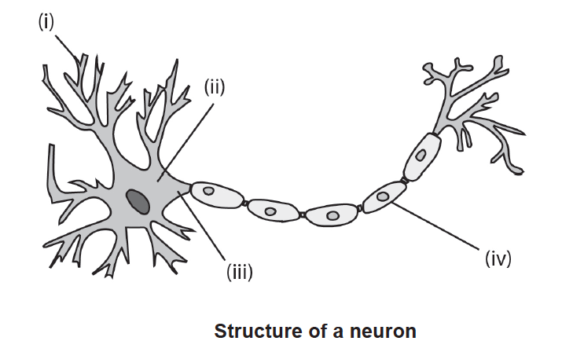

i. **Dendrite (1)**

ii. **Cell body (1)**

iii. **Axon (1)**

iv. **Myelin sheath / Schwann cell (1)**

(4)

1. Label the following diagram of the brain on the lines provided

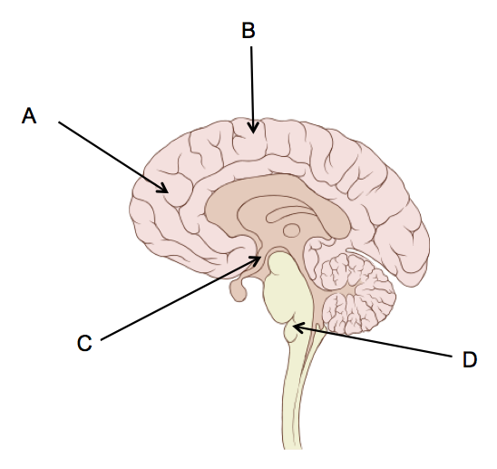

C **Hypothalamus (1)**

D **Brain stem (1)**

(2)

1. Uncle Toby has just had a stroke (a disruption of the blood supply to the brain) in his right hemisphere. List three difficulties he might now show because of the damage to his brain.

* **disruptions in movement in LHS of body**
* **disruptions in sensations in LHS of body**
* **difficulty in the area of creativity**
* **difficulty in the area of visual processing e.g. recognizing shapes and colours**
* **difficulty in the area of spatial ability**
* **difficulty in the area of music and/or art appreciation**
* **difficulty in the area of non verbal tasks, etc. (any 3 x 1)**

(3)

**Question 5 (3 marks)**

Sperry and Gazzaniga carried out a number of studies that examined hemispheric specialisation. They used split-brain patients. Some of the procedures and results from two of these studies are summarised in the table below.

|  |  |  |
| --- | --- | --- |
| Study Number | Details | Results of Study |
| 1 | Patients were required to focus on a central fixation point on a screen. Two different words were presented simultaneously on the screen, one to the left of the fixation point and one to the right of the fixation point. | Patients were only able to read and say the words that were presented to the right of the fixation point |
| 2 | Patients were required to focus on a central fixation point on a screen. Under the screen there was a selection of objects. Patients were presented with a picture of one of these objects on the screen to either the left or right of the fixation point. Patients were asked to reach under the screen and identify the pictured object by touching it. | * Patients were unable to name an object that was presented to the left of the fixation point but could identify the object with their left hands by touching it. * Patients were able to name objects that were presented to the right of the fixation point. * Patients often denied seeing anything at all when the object was presented to the left of the fixation point. |

Tick the correct answer:

1. The results of study number 1 suggest that:

* objects in the right side of the fixation point are processed by the right hemisphere.
* **the left hemisphere can process words and can also enable words to be verbalised.**
* the left hemisphere can process words but does not enable words to be verbalised.
* the right hemisphere is unable to process words when words are presented to both sides of the fixation point.

(1)

1. The results of study number 2 suggest that:

* the left hemisphere is responsible for coordinating movements in the left hand.
* the right hemisphere can identify the pictured object but the object cannot be named.
* only objects in the right side of the fixation point are received and processed by the primary visual cortex of the temporal lobe.
* **the left and right hemispheres can both name and identify objects by touch.**

(1)

1. The results of these two studies together suggest that the:

* **right hemisphere is responsible for verbalising objects and words.**
* left hemisphere is responsible for identifying objects with the left hand.
* left hemisphere is responsible for spatial reasoning and identifying objects.
* left hemisphere appears to make the executive decisions about whether or not an item is present

(1)

**End of Section Two**

**Section Three: Extended Answer (15 marks)**

This section contains one (1) question. Pages are included at the end of the questions for planning and writing your answers.

* Planning: If you use a page for planning, indicate this clearly at the top of the page.
* Answering the question: In the pages provided indicate clearly the number of the question you are answering.
* You should refer to relevant psychological concepts, theories and research in your answer.

You are a psychologist who has been asked to design a program to promote the psychological wellbeing of young people. After reading the psychological evidence you decide that the program will be based on exercise and will be called ‘Healthy body, healthy mind’. You must now write about the psychological evidence that shows that exercise is not only good for the body but also good for the mind, in order to convince your manager to provide the funding for the program.

In your answer you should provide an introduction that gives an overview of why the program will be based on exercise.

You need to include:

* **two** (2) specific examples of the benefits of exercise on psychological wellbeing.
* references to psychological evidence relevant to each example.

Student Name: Class:

|  |  |
| --- | --- |
| **Attributes** | **Marks** |
| **Introduction** | **2** |
| Detailed introduction | 2 |
| Basic, unelaborated introduction | 1 |
| No introduction | 0 |
| **For each of the two examples** | **5 x 2 = 10** |
| **Example One (McMillan and Holmes, 1984)** |  |
| Detailed description of one or more examples of relevant psychological research. (e.g. summary of key research findings as well as details of study and researcher) | 4 – 5 |
| Refers to one or more examples of psychological research but without any detail (e.g. name of researcher and/or basic description of the study or findings only | 2 – 3 |
| One or more personal or real life examples provided as evidence | 1 |
| No supporting psychological evidence, or all evidence is incorrect/irrelevant | 0 |
| **Example Two (Field, Diego, & Sanders, 2001)** |  |
| Detailed description of one or more examples of relevant psychological research. (e.g. summary of key research findings as well as details of study and researcher) | 4 – 5 |
| Refers to one or more examples of psychological research but without any detail (e.g. name of researcher and/or basic description of the study or findings only | 2 – 3 |
| One or more personal or real life examples provided as evidence | 1 |
| No supporting psychological evidence, or all evidence is incorrect/irrelevant | 0 |
| **Structure** | **3** |
| Well-constructed argument, well-developed sentences and paragraphs; uses appropriate psychological language with accurate spelling, grammar and paragraph structure. | 3 |
| Clear everyday language with adequate grammar, spelling, sentences and paragraph structures. | 2 |
| Poor literacy skills may interfere with the ability of the marker to understand the response (e.g. very poor spelling, grammar, very poor sentence and paragraph structure) | 1 |
| Response is unable to be understood. | 0 |
| Mark |  |

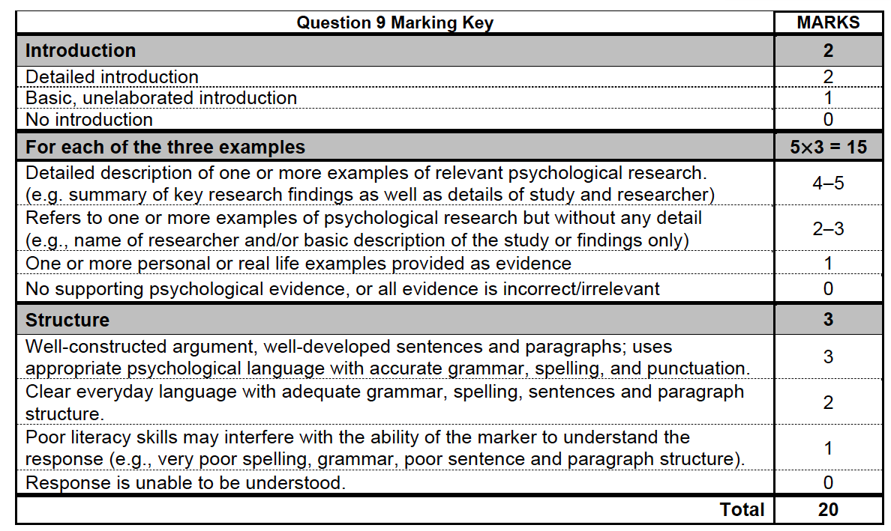

**This Page Is Intentionally Left Blank**